

BOWKER HALL (est.1957) - SOUTHERN VANCOUVER ISLAND AREA

1709 Monterey Ave, Victoria, BC V8R 5V6

**MAIN ENTRANCE OUTSIDE EXIT DOORS**

Bowker Hall is located in Oak Bay at 1709 Monterey Avenue. The hall is next door to Fireman’s Park, the Scout Hall, and the municipal police and fire stations. We are the building closest to the baseball park.

Driving time to Bowker Hall is about 10 minutes from downtown Victoria and about 45 minutes from the Swartz Bay ferry terminal. To reach the hall by bus, please see [www.bctransit.com/victoria](http://www.bctransit.com/victoria)

**Things to do within the neighbourhood**

|  |  |
| --- | --- |
| * Fireman’s Park * Oak Bay Recreation Centre (pool & showers) * Willows Beach * Oak Bay Marina * Gonzales Hill Park * Uplands Park | * Fairways grocery store * Art galleries on Oak Bay Avenue * Kiwanis Willows Beach Tea Room (Summer) * Greater Victoria Public Library-Oak Bay Branch * Centennial Trail * Anderson Hill Park |

**Things to do in downtown Victoria**

|  |  |
| --- | --- |
| * BC Legislature * Royal BC Museum * IMAX Theatre * Inner Harbour * Empress Hotel * Beacon Hill Park * Emily Carr House * Dallas Road waterfront | * Ogden Point Breakwater * Fisherman’s Wharf * Chinatown * Shopping on Government Street and Lower Johnson * Bay Center * Craigdarroch Castle * Victoria Art Gallery |

**Further Distance**

* Butchart Gardens
* Point Ellice House
* Whale Watching
* Zipline adventures at WildPlay or Adrena Line
* University of Victoria
* Mt. Tolmie or Pkols for beautiful views of Victoria

**SUPPLIED/NOT SUPPLIED – see forms provided upon booking for more details**

* Supplied – toilet paper, floor cleaner, toilet cleaner, bags for sanitary waste, coffee filters, bathroom paper towel
* Not Supplied – all consumables – food (including seasonings, sugar), dish soap, bleach, dish cloths, tea towels, paper towels, potholders, foil, flashlights, First Aid kit, rubber gloves, SOS pads, oven cleaner, compost bags and garbage bags, hand sanitizer, sanitizing spray, anti-bacterial wipes, food wrap
* No landline phone
* Crests are available to purchase from a basket in the kitchen for $3.50 each. Payment must be made on the same form as rental payment, please do not leave cash or cheques at the hall.

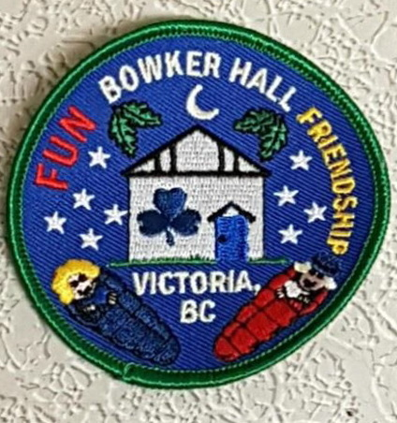

**MAIN FLOOR**

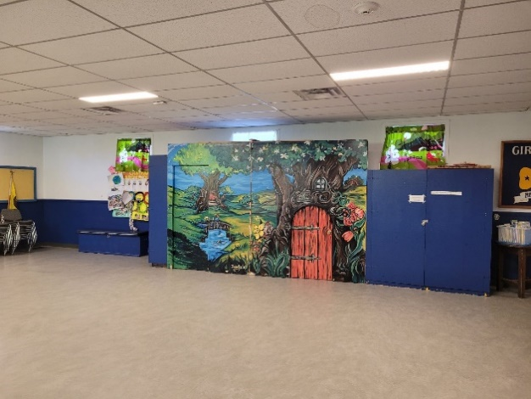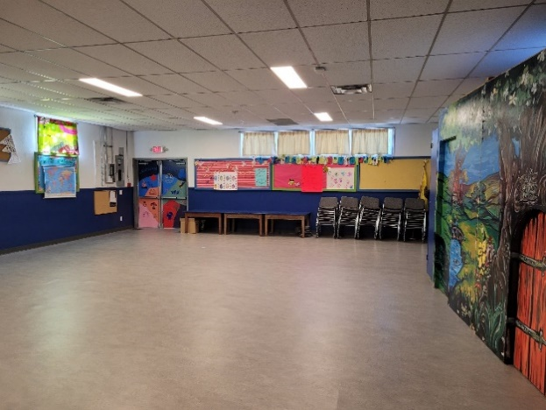

* Sleeping, eating and activities are accommodated in the large hall with an additional small meeting room upstairs
* Washroom facilities but no showers.
* Maximum overnight capacity is 24 people (youth & adults)
* Free parking available
* Free WiFi
* Audio Visual equipment available

**UPSTAIRS**

* Fully Equipped Kitchen with dishes and cutlery, cooking utensils, fridge, stove & microwave, toaster, kettle, coffee maker
* Recycling, garbage & compost must be taken with you unless you are travelling by bus and have made prior arrangements with the Bowker Hall Manager [ggcbowker@gmail.com](mailto:ggcbowker@gmail.com) to leave your garbage and recycling.

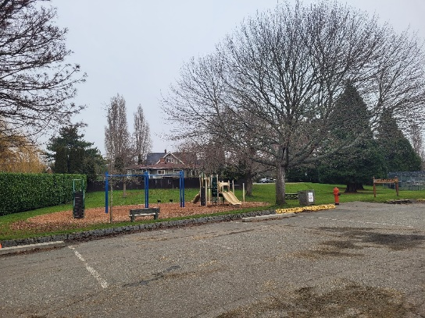

**KITCHEN** **PLAYGROUND** **SINKS NEAR MAIN ENTRANCE**

**BOOKING PROCEDURE** – Visit <https://www.svigirlguides.bc.ca/camp-booking-information>

* Upon confirmation of your booking you will receive further details about the camp, including arrangements for obtaining keys, paying your deposit and your fees. The deposit will be deducted from your camp fee total if you leave the site clean and secure and everything in good repair. Details of camp rental rates and subsidies for SVI Area members are at <https://www.svigirlguides.bc.ca/camps>